专题16 说明文
*** 考情分析 ***
年份 | 卷别 | 形式 | 话题
2022 | 2022年全国乙卷 | 图表类 | 学习活动状况描述
*** 写作指导 ***
【题型分析】
说明文是今年来高考英语书面表达比较常见的一种体裁，其特点是对事物或做事情的方法进行客观介绍。近两年高考英语说明文多以图画形式/应用文的形式出现，内容集中在反映社会现象、介绍方位地点和指导如何做事情以及介绍某种新产品，要求学生能够按照一定的说明顺序进行介绍和说明，以达到实际应用和交际的目的。
写说明文宜采用三段式：第一段主要介绍要说明的对象及说明的目的；第二段说明事物的主要特征或做事情的方法步骤；第三段进行总结概括。时态通常用一般现在时。
【写作方法】
写作时应遵循以下几个步骤：
1.仔细审题，明确说明对象，抓住要说明的事物或事理的主要特征。
2.选择合理的说明顺序（时间顺序、空间顺序或逻辑顺序）分层次进行说明，注意条理清晰。
3.选择恰当的说明方法，比如定义法、举例法、比较法和细节描述法等，不要遗漏主要内容。
4.根据说明顺序及内容确定过渡词和恰当的句型结构。文字应客观、简洁、明了，不要追求华丽和加入太多个人观点。
*** 素材宝库 ***
【介绍地理位置的说明文】
一）.介绍地理位置（location）
be located in… be situated in… stretches itself lazily along lie in…
坐落于……脚下/顶部…stands at the foot of/ on the top of…
二）.介绍人口（population）:
…has a large population of…,
（a city） with a population of…
三）.介绍面积（area）
has/covers an area of…square kilometers
（a city） with an area of…square kilometers
the size of our city is …
四）介绍历史history
…has a long history (of …years)
with a long history (of …years)
has witnessed too much coming and going in history
五）介绍交通transportation
交通便利…has convenient transportation
（a city） with convenient transportation both on land and water
坐汽车、火车、飞机到…
take a bus, a train or a plane to… go to …by bus/train/plane
六）介绍经济economy
经济迅速发展…economy has been developing rapidly
多次进入全国经济十强城市
…has been listed among the top ten strongest cities in economy several times
七）名胜古迹places of interest/ historical spots
1)The places around our city are rich in natural resources.
2)The city, known as…, attracts millions of visitors from all over the world.
3)The city is well-known / famous for its…/as…
4)The city is home to …
5) … is a must-see for tourists, as…
八）介绍天气
1.There is a variety of climate ( warm, dry, humid, cold, sunny, stormy, rainy…)
2.The average temperature of Hong Kong is about 22C . The rainy season is between May and July.
九）.Surroundings (周边环境)
1) stands, 2) surrounded by, 3) faces… 4）with…on its east/west/left/right
5))at the back of在……的后面 6)in front of在……的前面 7)in the north of在……的北部(内部)
8)on the south of在……的南方(接壤) 9)to the east of在……的东面(相离)
【写作模板】
（分析利弊型）
Nowadays many people prefer to_____________（某种行为） Generally, its advantages can be seen as follows. First, _____________。（优点之一）Besides, _____________。（优点之二）
But every coin has two sides. The negative aspects are also apparent. One of the important disadvantages is that_____________（第一个缺点）To make matters worse, _____________。（第二个缺点）
Through the above analysis, I think we should take it reasonably and do it according to the circumstances we are in. Only in this way, _____________•(对前景的预测）As for me, I would like to_____________（我的看法 。
（说明原因型）
These days we often hear that_____________。（提出论题）It is common that_____________，（说明现状）
As we know, _____________（大家熟知的一个事实）For one thing, _____________。（理由一）For another, _____________（理由二）What is more, _____________，（理由三） it is natural that_____________。（引起的后果）
In my opinion, we should_____________（解决方法）to improve the_____________ present situation. I do believe everything will be better in the future.
*** 高考真题精讲 ***
【2022年全国乙卷】
学校英文报正在开展以Learning English Beyond the Classroom为题的讨论。请使用图表中的调查结果写一篇短文投稿，内容包括：
1. 学习活动状况描述：
2. 简单评论;
3. 你的建议。
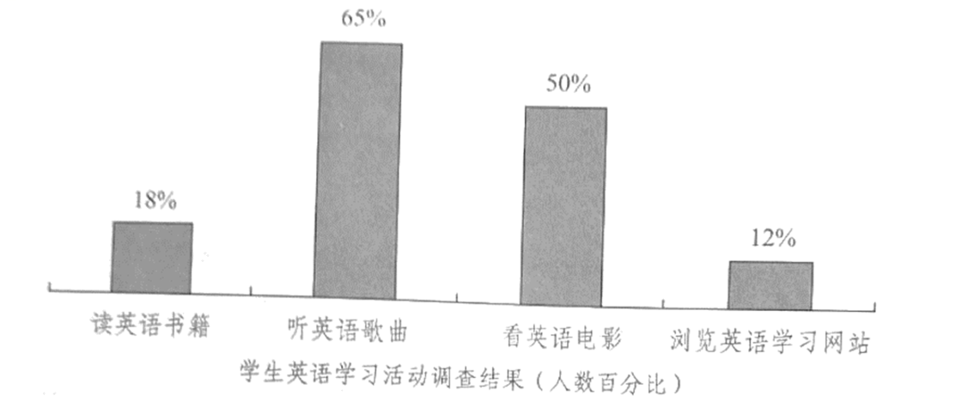
注意：
1. 词数100左右;
2. 短文的题目和首句已为你写好。
________________________________________________________________________________________________________________________________________________________________________________________________________________________________________________________________________________________________________________________________________________________________________________________________________________________________________________________________________________________________________________________________________________________________________________________________________________________________________________________________________________________________________________________________________________________________
【答案】
Learning English Beyond the Classroom
Nowadays, with the growing popularity of smartphones and computers, an increasing number of students are choosing to learn English beyond the classroom in various ways.
It can easily be seen that the percentage of students who choose listening to English songs and watching English movies is respectively 65% and 50%. However, those choosing reading English books and visiting English learning websites only account for 18% and 12%.
As far as I’m concerned, it is a disturbing trend. For students, what benefits most to their study is reading English books. Because of their lack of self-discipline, they’re more easily addicted to chatting online or playing games. It’s urgent for students themselves to improve their self-discipline, and it’s also urgent for parents and teachers to strengthen the guidance.
【分析】本篇书面表达属于说明文。要求考生请使用图表中的调查结果写一篇短文给学校英文报投稿。
【详解】1.词汇积累
选择：choose → select
提高：improve → strengthen
各种各样的：various → diverse
就我而言：as far as I’m concerned → from my perspective
2.句式拓展
简单句变复合句
原句：Nowadays, with the growing popularity of smartphones and computers, an increasing number of students are choosing to learn English beyond the Classroom in various ways.
拓展句：Nowadays, because smartphones and computers are becoming more and more popular, an increasing number of students are choosing to learn English beyond the Classroom in various ways.
【点睛】
【高分句型1】It can easily be seen that the percentage of students who choose listening to English songs and watching English movies is respectively 65% and 50%. (运用了it作形式主语，that引导主语从句以及who引导的定语从句)
【高分句型2】It's urgent for students themselves to improve their self-discipline (运用了it作形式主语，to improve their self-discipline为真正的主语)
*** 名校模拟题提升练 ***
【2024年高二（上）期末】
学校正在组织科技创新大赛，你想为日常生活中某件品（如钢笔、书包、鞋子…·）设计添加新功能来参赛。，请以“My Magic ”为题写一篇英语短文，介绍你的创意。
内容：
1.说明设计理由；
2.介绍新功能。
注意：
1.词数不少于120；
2.不能使用真实姓名和学校名称。________________________________________________________________________________________________________________________________________________________________________________________________________________________________________________________________________________________________________________________________________________________________________________________________________________________________________________________________________________________________________________________________________________________________________________________________________________________________________________________________________________________________________________________________________________________________
【答案】
My Magic Shoes
As is known to us all, shoes play an important role in our life, for it can protect our feet from being hurt. As a boy who has athlete's foot,I am looking forward to inventing a pair of shoes helping my feet keep dry and me walk conveniently. Therefore, this new kind of shoes has come into being recently.
To keep feet dry and comfortable,this new kind of shoes is equipped with a micro-fan. When you walk, a small machine changes the energy produced by walking into electric energy and stores it. If you stop walking, the micro-fan can work immediately to dry your feet. However, what amazes you most is the following new function. There is a special red button in each of the shoes. If the road you are walking is flat, you can press the red button, which helps your shoes change into a roller skate with two rollers appearing beneath your shoes, and you can reach your destination quickly. On arriving at your destination, press the red button again and the rollers will return to your shoes.
Such is my magic shoes.Do you like it or would you like to have a try?
【2024年高一（上）期末】
假设你是明启中学高三学生卢平，你校英语报向全体高三学生征文，题目为“My Teachers”。你有意投稿，撰写一篇文章，内容如下：
•对遇到过的老师进行分类
•具体描述每一类老师的特征（注意：不得透露老师的真实信息）________________________________________________________________________________________________________________________________________________________________________________________________________________________________________________________________________________________________________________________________________________________________________________________________________________________________________________________________________________________________________________________________________________________________________________________________________________________________________________________________________________________________________________________________________________________________
【答案】
In my previous 12-year study life I have met three types of teachers. All of them left me a deep impression.
The first type is very strict. It was my primary school Maths teacher. The first day I saw him, he made it a rule that all of us should put our hands on the desk and if anyone of us dare to copy others' homework, he would tell our parents. He was very strict but had a remarkable education effect.
The second type is very kind. It was my middle school PE teacher. He was in his twenties. Despite the fact that he was the teacher, he played basketball with us every day. Moreover, he bought us ice creams for many times.
The last type is the teachers who are just like friends. My senior high school teacher are all this type.Their class atmosphere was rather active and everyone of us were ready to interact with them. We learned a lot of knowledge as well as made friends with them. They were also ready to point us what the right road is.
The third type teacher is the one that every students want to have. But whatever a teacher's character is we should respect them because all teachers are eager to cultivate us.
【2024年高二期末】
根据调查，每次考试时总有些同学出现头晕、乏力、睡眠不足和食欲不振等“紧张情绪”。请你用英语写一篇短文，介绍一下你是如何对待考试及如何克服考试紧张情绪的。短文应包括以下内容：
1、平时努力学习，正确对待考试；
2、考前适当运动，正常作息；
3、睡前洗个热水澡、喝杯热牛奶有助于睡眠。
注意：1、文章开头已经给出，但不计入总词数；
2、词数：100左右。
How to overcome the pressure of exams
As we all know, most of us middle school students feel somehow nervous whenever we’re taking an important exam. ________________________________________________________________________________________________________________________________________________________________________________________________________________________________________________________________________________________________________________________________________________________________________________________________________________________________________________________________________________________________________________________________________________________________________________________________________________________________________________________________________________________________________________________________________________________________
【答案】
How to overcome the pressure of exams
As we all know, most of us middle school students feel somehow nervous whenever we’re taking an important exam. As a matter of fact, exams are no more than a means of evaluating, therefore, there is no need to worry too much about the results.
To avoid suffering from the pressure of exams, first of all, we should have a correct attitude towards exams and work hard every day. Besides, we’d better do proper outdoor exercise and have a regular timetable before exams. What’s more, a hot bath or a cup of hot milk before going to bed night may help you have a sound sleep.
So, my suggestion is: don’t worry about exams, try to relax yourself.

